# j0195384=TV Studio:

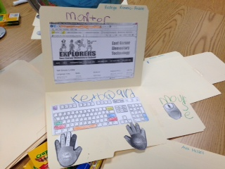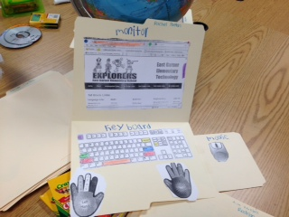

-My name is Ms. Smith and I work with students in the computer lab.  
-Here at East Garner we have a variety of technology items that we use such as:  
 -iPads, iPods, Interactive whiteboards, Clickers, computers, and more!

# Website:

* Below is the website that students use at school. It would be very useful for students to use at home or at the library!
* **eastgarner.weebly.com**

# Volunteers:

Parents: I can always use volunteers in the computer lab, so if you are interested in helping out you can email me at [csmith17@wcpss.net](mailto:csmith17@wcpss.net). Thanks!

# Important Dates:

October 3rd – Picture day!  
October 18th – Early Release  
October 28th – Teacher Workday  
October 30th – EGES PAC Night 6-7pm (Barwell Community Center)

This month on the Morning Show we are recognizing Hispanic Heritage Month and Disability Awareness month.

For Hispanic Heritage Month, we are going to have one of our ESL teachers share a new salsa step each day. Also, each day, we are going to have an Hispanic student share special facts about their culture such as information about the food, money, clothing, and flag.

For disability awareness month, we will be recognizing celebrities, athletes, and other famous people with disabilities.

# Student Work:

<First graders created their very own computers. They cut out and glued down their keyboards, monitors, and mouse, and colored the important keys on the keyboard. Pictures are shown to the left.

Parents: Please work with your students and help them memorize their Powerschool numbers. Students use this number to login to the computer and it is very important that they know their number.  
**What’s Happening in the Lab?**This month, students are learning about the important keys on the keyboard. They have been creating their very own computers where they color important keys such as Enter, Backspace, Space Bar, Escape, Shift, Caps Lock, and more! Quiz your child at home and see which keys they know!

# TV Studio:

# TV Studio:

# Students Login Numbers:

# Tech Info

Technology

Times

banner with apples and crayons

### East Garner Elementary School

Garner, NC

October 2013

Ms.Smith’s Technology Newsletter