# j0195384=TV Studio:

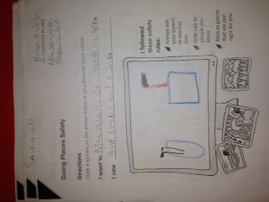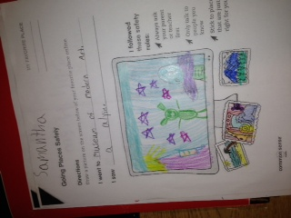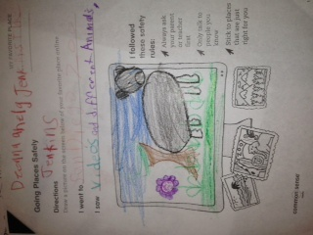

# Student Work:

First graders illustrated where they went on the Internet while reviewing their Internet safety rules.

This month on the Morning Show we are recognizing National Readers Week (November 12th- 15th ). Each day we will have a student describe one of their favorite books that they have read. The book will be featured and explained briefly.

-My name is Ms. Smith and I work with students in the computer lab.  
-Here at East Garner we have a variety of technology items that we use such as:  
 -iPads, iPods, Interactive whiteboards, Clickers, computers, and more!

# Website:

* Below is the website that students use at school. It would be very useful for students to use at home or at the library!
* **eastgarner.weebly.com**

# Volunteers:

Parents: I can always use volunteers in the computer lab, so if you are interested in helping out you can email me at [csmith17@wcpss.net](mailto:csmith17@wcpss.net). Thanks!

# Important Dates:

November 8th- Early Release  
November 11th- Holiday, No School  
November 14th- Literacy Night  
November 27th, 28th, 29th- Holiday, No School

Parents: Please work with your students and help them memorize their Powerschool numbers. Students use this number to login to the computer and it is very important that they know their number.  
**What’s Happening in the Lab?**This month, students are learning about how to stay safe on the Internet by only talking to people that they know, not sharing personal information, and sticking to websites that are just right for them. They are also learning about taking credit for what they create and giving others credit.

# TV Studio:

# TV Studio:

# Students Login Numbers:

# Tech Info

Technology

Times

banner with apples and crayons

### East Garner Elementary School

Garner, NC

November 2013

Ms.Smith’s Technology Newsletter